|  |  |  |
| --- | --- | --- |
| Name: Sarthak Agarwal | Roll No:I079 | MBA Tech IT |
|  |  |  |

Question 1:

Implement In-order Tree Traversal to print all nodes of a Binary Tree.

CODE IN JAVA:  
class Node {

int key;

Node left, right;

public Node(int item)

{

key = item;

left = right = null;

}

}

class BinaryTree {

Node root;

BinaryTree() { root = null; }

void printInorder(Node node)

{

if (node == null)

return;

printInorder(node.left);

System.out.print(node.key + " ");

printInorder(node.right);

}

void printInorder() { printInorder(root); }

public static void main(String[] args)

{

BinaryTree tree = new BinaryTree();

tree.root = new Node(1);

tree.root.left = new Node(2);

tree.root.right = new Node(3);

tree.root.left.left = new Node(4);

tree.root.left.right = new Node(5);

System.out.println(

"\nInorder traversal of binary tree is ");

tree.printInorder();

}

}

SS:

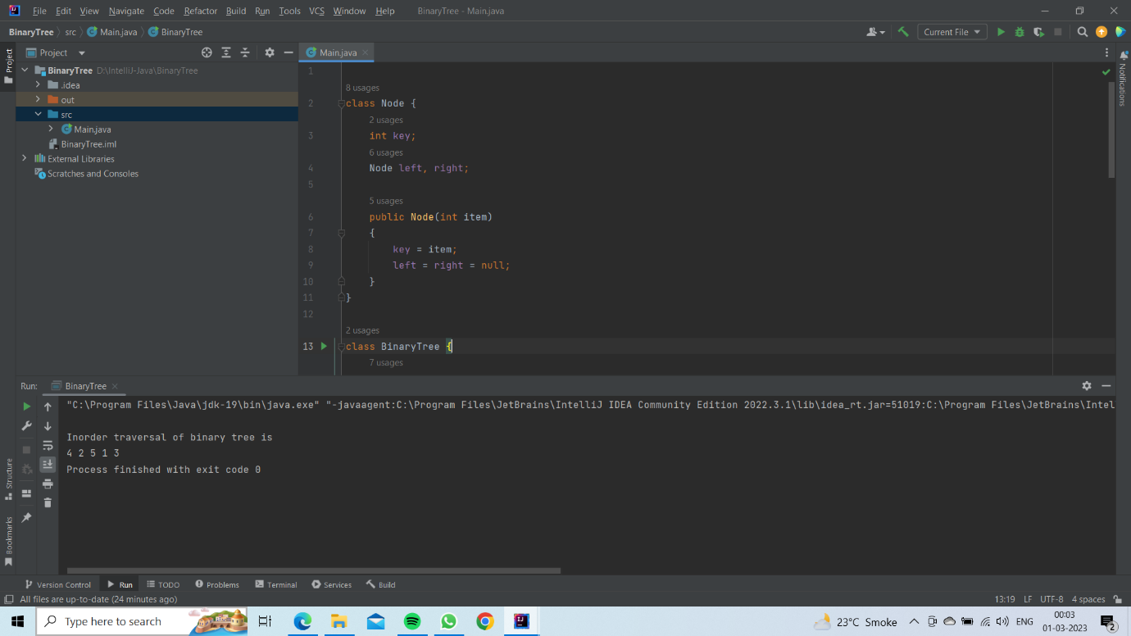

QUESTION 2:

Given 2 sorted arrays A and B with n and m elements respectively. A has enough space at the end of the array to fit in all elements of B. Write an

algorithm to merge the elements of A and B ensuring the resultant A is sorted as well. The code cannot use an extra array. Input: A = 1 3 5 6 8 - -

- B = 0 2 10 Output: A = 0 1 2 3 5 6 8 10

CODE IN JAVA:

class MergeArrays {

void moveToEnd(int mPlusN[], int size)

{

int i, j = size - 1;

for (i = size - 1; i >= 0; i--) {

if (mPlusN[i] != -1) {

mPlusN[j] = mPlusN[i];

j--;

}

}

}

void merge(int mPlusN[], int N[], int m, int n)

{

int i = n;

int j = 0;

int k = 0;

while (k < (m + n))

{

if ((i < (m + n) && mPlusN[i] <= N[j])

|| (j == n)) {

mPlusN[k] = mPlusN[i];

k++;

i++;

}

else

{

mPlusN[k] = N[j];

k++;

j++;

}

}

}

void printArray(int arr[], int size)

{

int i;

for (i = 0; i < size; i++)

System.out.print(arr[i] + " ");

System.out.println("");

}

public static void main(String[] args)

{

MergeArrays mergearray = new MergeArrays();

int mPlusN[] = { 2, 8, -1, -1, -1, 13, -1, 15, 20 };

int N[] = { 5, 7, 9, 25 };

int n = N.length;

int m = mPlusN.length - n;

mergearray.moveToEnd(mPlusN, m + n);

mergearray.merge(mPlusN, N, m, n);

mergearray.printArray(mPlusN, m + n);

}

}

SS:

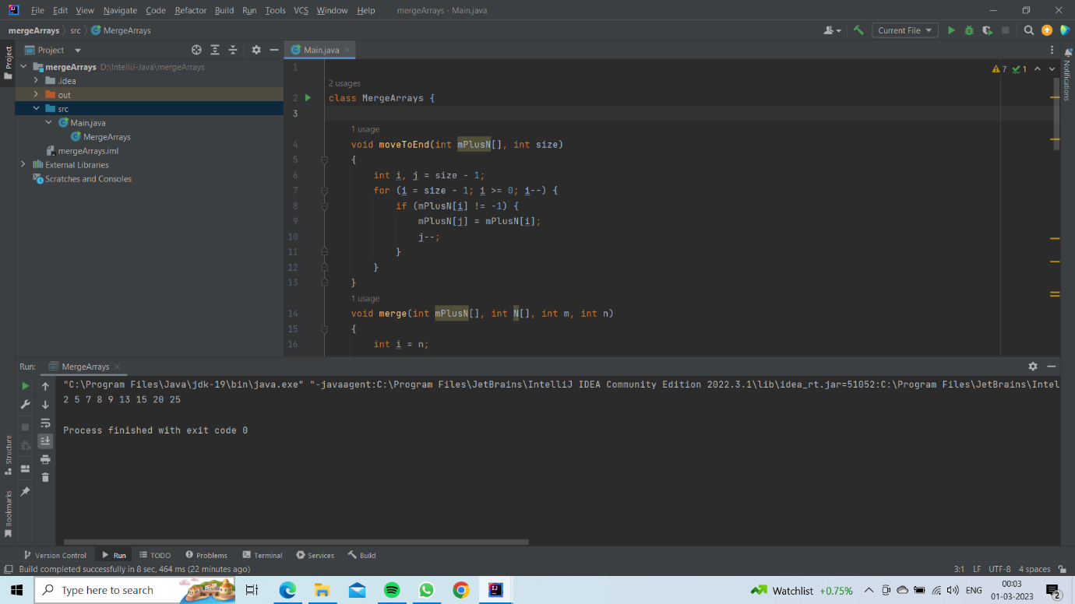

Question 3: (FOR FRONT END)

Let’s build a Feed app similar to the Facebook feed. You can make a web app or a mobile app. But it should fulfil at least the following

requirements

The user should be able create posts containing text, images or videos.

A user can view posts from other users.

Manage a database on these posts.

A user can filter/search through the posts shown on the feeds page. Once the above requirements are built, you can get creative on the UI

and on adding new features.

ANSWER:  
**HTML CODE:**

<!DOCTYPE html>

<html lang="en">

<head>

    <meta charset="UTF-8">

    <meta http-equiv="X-UA-Compatible" content="IE=edge">

    <meta name="viewport" content="width=device-width, initial-scale=1.0">

    <title>SocialBook</title>

    <link rel="stylesheet" href="style.css">

    <script src="https://kit.fontawesome.com/f2a9f352d3.js" crossorigin="anonymous"></script>

</head>

<body>

    <nav>

        <div class="nav-left">

<img src="images/logo.png" class="logo">

<ul>

    <li><img src="images/notification.png"></li>

    <li><img src="images/inbox.png"></li>

    <li><img src="images/video.png"></li>

</ul>

</div>

        <div class="nav-right">

            <div class="search-box">

                <img src="images/search.png">

                <input type="text" placeholder="Search">

            </div>

            <div class="nav-user-icon online">

                <img src="images/profile-pic.JPG">

            </div>

        </div>

    </nav>

    <div class="container">

<!-- left-sidebar--------------------------------------- -->

        <div class="left-sidebar">

            <div class="imp-links">

                <a href="#"><img src="images/news.png">Latest News</a>

                <a href="#"><img src="images/friends.png">Friends</a>

                <a href="#"><img src="images/group.png">Group</a>

                <a href="#"><img src="images/marketplace.png">Market Place</a>

                <a href="#"><img src="images/watch.png">Watch</a>

                <a href="#">See More</a>

            </div>

            <div class="shortcut-links">

            <p>Your Shortcuts</p>

            <a href="#"><img src="images/shortcut-1.png">Web Developers</a>

            <a href="#"><img src="images/shortcut-2.png">Stock Markets</a>

            <a href="#"><img src="images/shortcut-3.png">Latest Music</a>

            <a href="#"><img src="images/shortcut-4.png">Netflix India</a>

            </div>

        </div>

                    <!-- main content--------------------------------------- -->

        <div class="main-content">

<div class="story-gallery">

    <div class="story story1">

        <img src="images/upload.png">

        <p>Post Story</p>

    </div>

    <div class="story story2" >

        <img src="images/member-1.png">

        <p>Saher Caroli</p>

    </div>

    <div class="story story3">

        <img src="images/member-2.png">

        <p>Uday Pratap</p>

    </div>

    <div class="story story4">

        <img src="images/member-3.png">

        <p>Aryaman Nagdev</p>

    </div>

    <div class="story story5">

        <img src="images/member-4.png">

        <p>Tejas Bhardwaj</p>

    </div>

</div>

<div class="write-post-container">

    <div class="user-profile">

        <img src="images/profile-pic.JPG">

        <div>

            <p>Sarthak Agarwal</p>

            <small>Public <i class="fa-solid fa-angle-down"></i></small>

        </div>

    </div>

    <div class="post-input-container">

        <textarea rows="3" placeholder="What's on your mind John?" ></textarea>

        <div class="add-post-links">

            <a href="#" id="sar">

                <img src="images/live-video.png">Live Video<a>

                <img src="images/photo.png">Photo Video<a>

                <img src="images/feeling.png">Feeling Activity</a>

        </div>

    </div>

</div>

    <div class="post-container">

        <div class="post-row">

            <div class="user-profile">

                <img src="images/profile-pic.JPG">

                <div>

                    <p>Sarthak Agarwal</p>

                    <span>January 24 2023,13:40 pm</span>

                </div>

            </div>

            <a href="#">

                <i class="fa-solid fa-ellipsis"></i>

            </a>

        </div>

        <p class="post-text">Subscribe ,<span>@sarthakagarwal</span> Youtube Channel

        to watch more videos on blogging and tourism.<a href="#">#BLOGGING</a>

    <a href="#">#YoutubeChannels</a></p>

    <img src="images/feed-image-1.png" class="post-img">

    <div class="post-row">

        <div class="activity-icons">

<div><img src="images/like-blue.png" >120</div>

<div><img src="images/comments.png" >45</div>

<div><img src="images/share.png" >20</div>

        </div>

        <div class="post-profile-icon">

            <img src="images/profile-pic.JPG" > <i class="fa-solid fa-angle-down"></i>

        </div>

    </div>

    </div>

    <div class="post-container">

        <div class="post-row">

            <div class="user-profile">

                <img src="images/profile-pic.png">

                <div>

                    <p>Aryaman Nagdev</p>

                    <span>February 28 2023,13:40 pm</span>

                </div>

            </div>

            <a href="#">

                <i class="fa-solid fa-ellipsis"></i>

            </a>

        </div>

        <p class="post-text">Subscribe ,<span>@sarthakagarwal</span> Youtube Channel

        to watch more videos on blogging and tourism.<a href="#">#BLOGGING</a>

    <a href="#">#YoutubeChannels</a></p>

    <img src="images/feed-image-1.png" class="post-img">

    <div class="post-row">

        <div class="activity-icons">

<div><img src="images/like-blue.png" >120</div>

<div><img src="images/comments.png" >45</div>

<div><img src="images/share.png" >20</div>

        </div>

        <div class="post-profile-icon">

            <img src="images/profile-pic.JPG" > <i class="fa-solid fa-angle-down"></i>

        </div>

    </div>

    </div>

        </div>

                    <!-- right-sidebar--------------------------------------- -->

        <div class="right-sidebar">

            <div class="sidebar-title">

                <h4>Events</h4>

            <a href="#">See All</a>

            </div>

            <div class="event">

                <div class="left-event">

                    <h3>18</h3>

                <span>March</span>

                </div>

                <div class="right-event">

                    <h4>Social Media</h4>

                <p><i class="fa-solid fa-location-dot"></i> JVPD Ground,Mumbai</p>

                <a href="#">More Info</a>

                </div>

            </div>

            <div class="event">

                <div class="left-event">

                    <h3>22</h3>

                <span>June</span>

                </div>

                <div class="right-event">

                    <h4>Mobile Marketting</h4>

                <p><i class="fa-solid fa-location-dot"></i> JVPD Ground,Mumbai</p>

                <a href="#">More Info</a>

                </div>

            </div>

            <div class="right-sidebar">

                <div class="sidebar-title">

                    <h4>Advertisment</h4>

                <a href="#">Close</a>

                </div>

                <img src="images/advertisement.png" class="sider-ads">

                <div class="right-sidebar">

                    <div class="sidebar-title">

                        <h4>Conversation</h4>

                    <a href="#">Hide Chat</a>

                    </div>

                    <div class="online-list">

                        <div class="online">

                            <img src="images/member-1.png">

                        </div>

                        <p>Saher Caroli</p>

                    </div>

                    <div class="online-list">

                        <div class="online">

                            <img src="images/member-2.png">

                        </div>

                        <p>Uday Pratap</p>

                    </div>

                    <div class="online-list">

                        <div class="online">

                            <img src="images/member-1.png">

                        </div>

                        <p>Navya Jain</p>

                    </div>

        </div>

    </div>

</body>

</html>

**CSS CODE:**

*{

    margin: 0;

    padding:0;

    font-family: 'poppins',sans-serif;

    box-sizing: border-box;

}

body{

    background: #efefef;;

}

nav{

    display: flex;

    align-items: center;

    justify-content: space-between;

    background-color: #1876f2;

    padding: 5px 5%;

    position: sticky;

    top: 0;

    z-index: 100;

}

.logo{

    width: 160px;

    margin-right: 45px;

}

.nav-left,.nav-right{

    display:flex;

    align-items:center;

}

.nav-left ul li{

    list-style: none;

    display: inline-block;

}

.nav-left ul li img{

    width: 28px;

    margin: 0 15px;

}

.nav-user-icon img{

    width: 40px;

    border-radius: 50%;

    cursor: pointer;

}

.nav-user-icon{

    margin: 30px;

}

.search-box{

    background: #efefef;

width:350px;

border-radius: 20px;

display: flex;

align-items: center;

padding: 0 15px;

}

.search-box img{

    width: 18px;

}

.search-box input{

    width: 100%;

    background: transparent;

    padding:10px;

    outline: none;

    border:0;

}

.online{

    position: relative;

}

.online:after{

    content: '';

    width: 7px;

    height: 7px;

    border: 2px solid #fff;

    border-radius:50%;

    background: #41db51;

position: absolute;

top: 0;

right: 0;

}

.container{

    display: flex;

    justify-content: space-between;

padding: 13px 5%;

}

.left-sidebar{

    flex-basis: 25%;

    position: sticky;

    top: 70px;

    align-self: flex-start;

}

.right-sidebar{

    flex-basis: 25%;

    position: sticky;

    top: 70px;

    align-self: flex-start;

    background-color: #fff;

    padding: 20px;

    border-radius: 4px;

    color:#626262

}

.main-content{

    flex-basis: 47%;

}

.imp-links a,.shortcut-links a{

    text-decoration: none;

    display: flex;

    align-items: center;

margin-bottom: 30px;

color: #626262;

width: fit-content;

}

.imp-links a img{

    width: 25px;

    margin-right: 15px;

}

.imp-links a:last-child{

    color: #1876f2;

}

.imp-links{

    border-bottom: 1px solid #ccc;

}

.shortcut-links a img{

    width: 40px;

    border-radius: 4px;

    margin-right: 15px;

}

.shortcut-links p{

    margin: 25px 0;

    color: #626262;

    font-weight: 500;

}

.sidebar-title{

    display: flex;

    align-items: center;

    justify-content: space-between;

    margin-bottom: 18px;

}

.right-sidebar h4{

    font-weight: 600;

    font-size: 16px;

}

.sidebar-title a{

    text-decoration: none;

    color: #1876f2;

    font-size: 12px;

}

.event{

    display: flex;

    font-size: 14px;

    margin-bottom: 20px;

}

.left-event{

    border-radius: 10px;

    height: 65px;

    width: 65px;

    margin-right: 15px;

    padding-top:10px ;

    text-align: center;

    position: relative;

    overflow: hidden;

    box-shadow: 0 0 10px rgba(0, 0, 0, 0.1);

}

.event p{

    font-size: 12px;

}

.event a{

    font-size: 12px;

    text-decoration: none;

    color: #1876f2;

}

.left-event span{

    position: absolute;

    bottom: 0;

    left: 0;

    width: 100%;

    background: #1876f2;

    color: #fff;

    font-size: 10px;

    padding: 4px 0;

}

.sider-ads{

    width: 100%;

    margin-bottom: 20px;

    border-radius: 4px;

}

.online-list{

    display: flex;

    align-items: center;

    margin-bottom: 20px;

}

.online-list .online img{

    width: 40px;

    border-radius: 50px;

}

.online-list .online{

    width: 40px;

    border-radius: 50%;

    margin-right: 15px;

}

.online-list .online::after{

    top:unset;

    bottom: 0;

}

.story-gallery{

    display: flex;

    justify-content: space-between;

    margin-bottom: 20px;

}

.story{

    flex-basis: 18%;

    padding-top: 32%;

    position: relative;

    background-position: center;

    background-size: cover;

    border-radius: 10px;

}

.story img{

    position: absolute;

    width: 45px;

    border-radius: 50%;

    top:10px;

    left: 10px;

    border-radius: 5px solid #626262;

}

.story p{

    position: absolute;

    bottom: 10px;

    width: 100%;

    text-align: center;

    color: #fff;

    font-size: 14px;

}

.story1{

    background-image: linear-gradient(transparent,rgba(0,0,0,00.5)), url(images/profile-pic.JPG);

}

.story2{

    background-image: linear-gradient(transparent,rgba(0,0,0,00.5)), url(images/status-2.png);

}

.story3{

    background-image: linear-gradient(transparent,rgba(0,0,0,00.5)), url(images/status-3.jpg);

}

.story4{

    background-image: linear-gradient(transparent,rgba(0,0,0,00.5)), url(images/status-4.jpg);

}

.story5{

    background-image: linear-gradient(transparent,rgba(0,0,0,00.5)), url(images/status-5.jpg);

}

.story.story1 img{

top:unset;

left: 50%;

bottom: 40px;

transform: translateX(-50%);

border: 0;

width: 35px;

}

.write-post-container{

    width: 100%;

    background-color: #fff;

    border-radius: 6px;

    padding: 20px;

    color: #626262;

}

.user-profile{

    display: flex;

    align-items: center;

}

.user-profile img{

    width: 45px;

    border-radius: 50%;

    margin-right: 10px;

}

.user-profile p{

    margin-bottom: -5px;

    font-weight: 500;

    color: #626262;

}

.user-profile small{

    font-size: 12px;

}

.post-input-container{

    padding-left:55px;

    padding-top: 20px;

}

.post-input-container textarea{

    width: 100%;

    border:0;

    outline: 0;

    border-bottom: 1px sol1#ccc;

    background: transparent;

    resize: none;

}

.add-post-links{

    display: flex;

    margin-top: 10px;

}

.add-post-links a{

    text-decoration: none;

    display: flex;

    align-items: center;

    color: #626262;

    margin-right: 30px;

    font-size: 13px;

}

.add-post-links a img{

    width: 20px;

    margin-right: 10px;

}

.post-container{

    width: 100%;

    background: #fff;

    border-radius: 6px;

    padding:20px;

    color: #626262;

    margin: 20px 0;

}

.user-profile span{

    font-size: 13px;

    color: #9a9a9a;

}

.post-text{

    color:#9a9a9a;

    margin: 15px 0;

    font-size: 15px;

}

.post-text span{

    color:#626262;

    font-weight: 500;

}

.post-text a{

    color:#1876f2;

    text-decoration: none;

}

.post-img{

    width: 100%;

    border-radius: 4px;

    margin-bottom: 5px;

}

.post-row{

    display: flex;

    align-items: center;

    justify-content: space-between;

}

.activity-icons div img{

    width: 18px;

    margin-right: 10px;

}

.activity-icons div{

    display: inline-flex;

    align-items:center ;

    margin-right: 30px;

}

.post-profile-icon{

    display: flex;

    align-items: center;

}

.post-profile-icon img{

    width: 20px;

    border-radius: 50%;

    margin-right: 5px;

}

SS:

